**Social Media Dashboard**

## A MINI PROJECT REPORT

***Submitted by***

## Group/Team No: G21/T5

|  |  |
| --- | --- |
| **Ishit Sharma:** | *2310991851* |
| **Jagjot Singh:** | *2310991852* |
| **Jai Anand:** | *2310991853* |
|  |  |

***in partial fulfilment for the award of the degree of***

## BACHELOR OF ENGINEERING

***in***

## Computer Science And Engineering



**CHITKARA UNIVERSITY**

**CHANDIGARH-PATIALA NATIONAL HIGHWAY RAJPURA (PATIALA) PUNJAB-140401 (INDIA)**

**October, 2023**

Page - 1

# ABSTRACT

The Social Media Dashboard Project aims to develop a comprehensive and user-friendly platform for individuals, businesses, and organizations to efficiently manage and analyze their social media presence across various platforms. In today's digital age, social media has become a cornerstone of communication and marketing strategies, making it essential to have a centralized tool that simplifies monitoring, engagement, and performance assessment.

The design process began with requirements gathering, including identifying the key features and functionality required for the Social Media Dashboard. A user interface design was then created using HTML, CSS, and JavaScript to provide a visually appealing and user-friendly interface. The HTML code was used to structure the content of the Social Media Dashboard, while the CSS was used to style the interface and make it more visually appealing. The JavaScript code was used to add functionality to the Tracker.

The Social Media Dashboard was developed to be responsive and compatible with all major web browsers. The functionality and usability of the Social Media Dashboard were tested extensively to ensure that it was effective and user- friendly.

# TABLE OF CONTENTS

|  |  |  |
| --- | --- | --- |
| **S. No.** | **SECTION** | **Page No.** |
| **1.** | **Acknowledgement** | **4** |
| **2.** | **Introduction** | **5 - 6** |
| **3.** | **Problem Statement** | **7** |
| **4.** | **Technical Details** | **8-13** |
| **5.** | **Key Feature** | **14** |
| **6.** | **Project Advantages** | **15** |
| **7.** | **Result** | **16** |
| **8.** | **Output** | **17 - 20** |
| **9.** | **Future Scope** | **21** |
| **10.** | **Conclusion** | **22** |
| **11.** | **References** | **23** |

# ACKNOWLEDGEMENT

I would like to take this opportunity to express my heartfelt gratitude to everyone who has supported and helped me during the course of this project.

First and foremost, I would like to thank **Chitkara University** for providing me with the opportunity to pursue this project and for their guidance and support throughout the duration of this project.

I would also like to express my sincere thanks to **Associate Professor**, *Dr. Bhisham Sharma*, for his constant encouragement, guidance, and valuable inputs throughout the project. His insights and suggestions were crucial in shaping the direction of this project.

Additionally, I would like to thank all the faculty members of the Department of Computer Science for

their invaluable support and encouragement throughout the project.

Last but not least, I would like to express my sincere thanks to my team members who worked tirelessly on this project. Their dedication and hard work made this project a success.

# INTRODUCTION

A Social Media Dashboard is a tool or application designed to monitor and manage your social media presence and activities. It typically provides a centralized platform where individuals or businesses can track and analyze their social media performance, engagement, and interactions across various social media platforms. Some common features of a social media dashboard include:

1. **Social Media Monitoring:** It allows users to monitor mentions, comments, and conversations about their brand or topics of interest on social media platforms.

3. **Analytics and Insights:** Social media dashboards offer data analytics and reporting tools to measure key performance metrics like follower growth, engagement rates, reach, and more. These insights help users understand the effectiveness of their social media strategies.

4. **Content Management:** Users can store and organize content, such as images and videos, for easy access and sharing on social media.

5. **Competitor Analysis:** Some dashboards offer features to track and analyze the social media activities of competitors, helping users stay competitive in their industry.

6. **Audience Engagement:** Engage with your followers, respond to comments, and interact with your audience directly through the dashboard.

7. **Campaign Tracking:** Monitor the performance of social media advertising campaigns, track ad spend, and measure ROI.

8. **Integration:** Many social media dashboards integrate with other marketing tools and platforms, such as email marketing software, CRM systems, and e-commerce platforms, for a more comprehensive view of your digital marketing efforts.

Overall, a social media dashboard is a valuable tool for individuals and businesses looking to streamline their social media management, improve their online presence, and make data-driven decisions to enhance their social media strategies.

### Overview of the Project's Objectives :

The objective of this project is to design and implement an Social Media Dashboard using modern web development technologies such as HTML, CSS, and JavaScript. The project will involve gathering requirements, creating a user interface design, and implementing the Social Media Dashboard.

### Scope of the Project:

The scope of the project includes testing the Social Media Dashboard’s functionality and usability to ensure that it provides value to the user and meets the project’s objectives.

### Common Features:

* Multi-Platform Integration: The ability to connect and manage multiple social media platforms, such as Facebook, Twitter, Instagram, LinkedIn, and others, from a single dashboard.
* Real-time Updates: Providing real-time or near-real-time data updates to keep users informed about the latest social media activity
* Customizable Dashboards: Allowing users to customize their dashboard layout, including which metrics and data they want to see at a glance.
* Analytics and Reporting: Robust analytics tools that provide insights into engagement metrics, audience demographics, and performance trends.
* Social Listening: Monitoring and tracking brand mentions, keywords, and hashtags across social media to gauge sentiment and engagement.
* Competitor Analysis: Tools for tracking and comparing the performance of competitors on social media.
* Audience Insights: Data on audience demographics, behaviors, and preferences to inform content creation and targeting.
* Campaign Tracking: The ability to monitor the performance of social media advertising campaigns, including ad spend and ROI.
* Content Management: A media library to store and organize images, videos, and other content for easy access and sharing

# PROBLEM STATEMENT

**"**Social Media Dashboard" aims to address the following problem:

**Background Information and Research:**

In recent years, the use of social media has become an integral part of our personal

and professional lives. Individuals, businesses, and organizations utilize multiple social media

platforms to connect with their audiences, promote products or services, and share content.

However, managing multiple social media accounts efficiently has become increasingly

challenging due to several factors:

1) Platform Proliferation: The number of social media platforms has grown significantly, each with its own unique features, algorithms, and analytics tools. This makes it difficult for users to keep track of their performance and engagement across all platforms.

2) Data Overload: Monitoring and analyzing the vast amount of data generated on social media, such as likes, comments, shares, and impressions, can be overwhelming. Without a centralized tool, users may miss important insights and trends.

3) Inconsistent Branding: For businesses and organizations, maintaining a consistent brand image across different social media platforms is crucial. Failing to do so can dilute brand identity and impact customer perception.

4) Time-Consuming Tasks: Posting content, scheduling updates, responding to messages, and analyzing performance metrics require substantial time and effort when managing multiple accounts individually. This can lead to inefficiencies and decreased productivity.

# TECHNICAL DETAILS

The technical details of this project involve :-

1. **HTML:**
   * The HTML code includes the structure of the web page, defining elements such as the header, container, various sections, forms, buttons, and links.
   * It incorporates forms for password reset and likely user login.
2. **CSS:**
   * CSS is used for styling the HTML elements, providing a visually appealing and consistent layout.
   * It includes styling for a light/dark mode switcher.
   * Different styles are applied to various components like cards, buttons, headers, and form elements.
   * The CSS file defines variables for colors, making it easy to switch between light and dark themes.
3. **JavaScript:**
   * JavaScript is used for dynamic behavior on the client side.
   * There's a theme switcher that toggles between light and dark modes using local storage to persist the user's choice.
   * Socket.io is used to establish real-time bidirectional communication between the client and server.
   * It includes scripts for handling form submissions, toggling the light/dark mode, and managing real-time chat functionality.
4. **Socket.io:**
   * Socket.io is a JavaScript library for real-time web applications. It enables real-time, bidirectional, and event-based communication.
5. **Server-side code:**
   * There's a Node.js server using the Socket.io library.
   * It handles socket connections, new user join events, message sending, and user leave events in real-time.
6. **Responsive Design:**
   * The project is designed to be responsive, with styles and layouts adjusting based on the screen size.
7. **Fonts and Icons:**
   * The project uses the "Inter" font from Google Fonts.
   * Icons are included for various social media platforms.
8. **External Libraries:**
   * jQuery is included via a CDN (Content Delivery Network) for DOM manipulation and interaction.
9. **Design Patterns:**
   * The project seems to follow a modular design pattern, with separate sections for different functionalities like cards, overview, and chat.
10. **Colors and Theming:**

* Colors are defined using custom properties (CSS variables), allowing for easy theming by changing variable values.

## Tags used in Project:

### HTML Tags used :

* 1. Document Structure:
  2. `<!DOCTYPE html>`: Document type declaration.
  3. `<html>`: Root element.
  4. `<head>`: Contains metadata about the document.
  5. `<meta>`: Meta-information about the HTML document.
  6. `<title>`: Specifies the title of the document.
  7. `<link>`: Defines the relationship between the current document and external resources (stylesheets, icons).
  8. Body Structure:
  9. `<body>`: Contains the content of the document.
  10. `<header>`: Represents the header of the document.
  11. `<div>`: A generic container for grouping elements.
  12. `<h1>`, `<h2>`, `<h3>`, `<h4>`: Heading elements.
  13. `<span>`: Inline container used to group elements and apply styles.
  14. `<p>`: Paragraph element.
  15. `<form>`: Represents an HTML form.
  16. `<input>`: Input field within a form.
  17. `<button>`: Represents a clickable button.
  18. `<a>`: Anchor element for creating hyperlinks.
  19. Script Tags (JavaScript):
  20. `<script>`: Embeds or references an external script.
  21. Link Tags (External Resources):
  22. `<link>`: Links to external stylesheets.
  23. Script Tags (External Libraries):
  24. `<script>`: Links to external JavaScript libraries (e.g., jQuery).
  25. Socket.io Script Tag:
  26. `<script>`: Includes the Socket.io library.

### CSS Attributes used :

* 1. Font Styles:
  2. `font-family`: Specifies the font for an element.
  3. `font-size`: Sets the size of the font.
  4. `font-weight`: Sets the thickness of the font characters.
  5. `color`: Defines the text color.
  6. Container Styles:
  7. `display`: Specifies the type of box used for an HTML element.
  8. `position`: Sets the positioning method of an element.
  9. `margin`: Defines the margin outside the border.
  10. `padding`: Defines the padding inside the border.
  11. `border-radius`: Creates rounded corners for an element.
  12. `background-color`: Sets the background color.
  13. Header Styles:
  14. `border-bottom-left-radius`, `border-bottom-right-radius`: Creates rounded corners for the header.
  15. `background-color`: Sets the background color of the header.
  16. `grid-template-columns`: Defines the number and size of columns in a grid container.
  17. Switch Styles:
  18. `height`, `width`: Sets the dimensions of the switch.
  19. `background`: Defines the background gradient of the switch.
  20. `border-radius`: Creates rounded corners for the switch.
  21. `cursor`: Specifies the type of cursor to be displayed.
  22. Card Styles:
  23. `border-radius`: Creates rounded corners for the cards.
  24. `padding`: Defines the padding inside the cards.
  25. `text-align`: Sets the horizontal alignment of text.
  26. Media Queries:
  27. `@media`: Defines a media query to apply styles based on the device characteristics.
  28. Variable Definitions:
  29. `:root`: Defines global CSS variables.
  30. `--variable-name`: Declares a CSS variable.
  31. Hover Styles:
  32. `:hover`: Applies styles when an element is hovered.

### JAVA Events used :

1. DOMContentLoaded Event:

- Ensures that the JavaScript code executes after the HTML document is fully loaded.

2. Click Event:

- Handles clicks on specific elements, such as dropdown toggles and options.

3. Submit Event:

- Manages form submissions, preventing the default form behavior and executing custom code.

4. Change Event:

- Detects changes in the state of an input element, like the light mode switch.

5. Socket.IO Events:

- Specific events for real-time communication in a chat application, including user joining (`new-user-joined`), sending messages (`send`), user joining notifications (`user-joined`), receiving messages (`receive`), and user leaving notifications (`left`).

# KEY FEATURES

* Multi-Platform Integration: The ability to connect and manage multiple social media platforms such as Facebook, Twitter, Instagram, LinkedIn, YouTube, and more from a single dashboard.
* Real-time Analytics: Access to real-time data and analytics, including metrics like engagement rates, follower growth, likes, shares, comments, and click-through rates.
* Monitoring Mentions and Comments: Tracking mentions of your brand, products, or keywords across social media, and monitoring comments and messages for timely responses.
* Competitor Analysis: Tools to analyze the social media performance of your competitors, benchmarking your metrics against theirs.
* Customizable Reporting: Generating customizable reports with visual graphs and charts for a comprehensive view of your social media performance, suitable for internal use or client reporting.
* Social Listening: The ability to monitor conversations and trends related to your industry or brand, providing insights into what's being discussed on social media.
* Influencer Collaboration: Identifying and connecting with potential influencers for partnerships and collaborations.
* Keyword Tracking: Tracking specific keywords or hashtags to gauge their popularity and relevance in your industry or niche.
* Audience Insights: Gathering data on your audience demographics, interests, and behaviors to refine your social media strategy.
* Content Performance Analysis: Evaluating the performance of individual posts, including which content types (videos, images, links, etc.) are most effective.
* CRM Integration: Integrating with customer relationship management (CRM) systems to better manage interactions with customers and leads.
* Mobile Accessibility: Ensuring that the dashboard is accessible and functional on mobile devices for on-the-go management.

**Using an Social Media Dashboard offers several advantages:**

* **Centralized Management:** A social media dashboard provides a centralized platform for managing multiple social media accounts and platforms from a single location. This streamlines the management process and saves time.
* **Efficient Scheduling:** You can schedule posts and content in advance, ensuring a consistent and timely presence on social media, even during non-working hours.
* **Real-time Analytics:** Social media dashboards offer real-time analytics and performance metrics, allowing you to track the impact of your social media efforts as they happen.
* **Data-Driven Decision Making:** Access to data and insights enables data-driven decision-making, helping you refine your social media strategy based on what works best.
* **Competitor Analysis:** You can monitor and analyze your competitors' social media activities, gaining insights into their strategies and performance.
* **Improved Engagement:** By analyzing audience behavior and preferences, you can tailor your content to increase engagement and interaction with your followers.
* **Time Savings:** Automation and scheduling features help save time by reducing the need for manual posting and monitoring.

# RESULT

The Social Media Dashboard Project aims to develop a comprehensive and user-friendly platform for individuals, businesses, and organizations to efficiently manage and analyze their social media presence across various platforms. In today's digital age, social media has become a cornerstone of communication and marketing strategies, making it essential to have a centralized tool that simplifies monitoring, engagement, and performance assessment.

The layout was intentionally kept simple and clean, so as not to overwhelm the user, while the content was designed to be attention-grabbing and exciting. The use of colors and graphics helped draw the user's attention to the website.

The team implemented the Social Media Dashboard using HTML and CSS.

* HTML was used to create the structure and content of the web page.
* The CSS code was used to style the content.
* JavaScript was used to add Function like Dark Mode to the website

# OUTPUT:

# MAIN WEBSITE

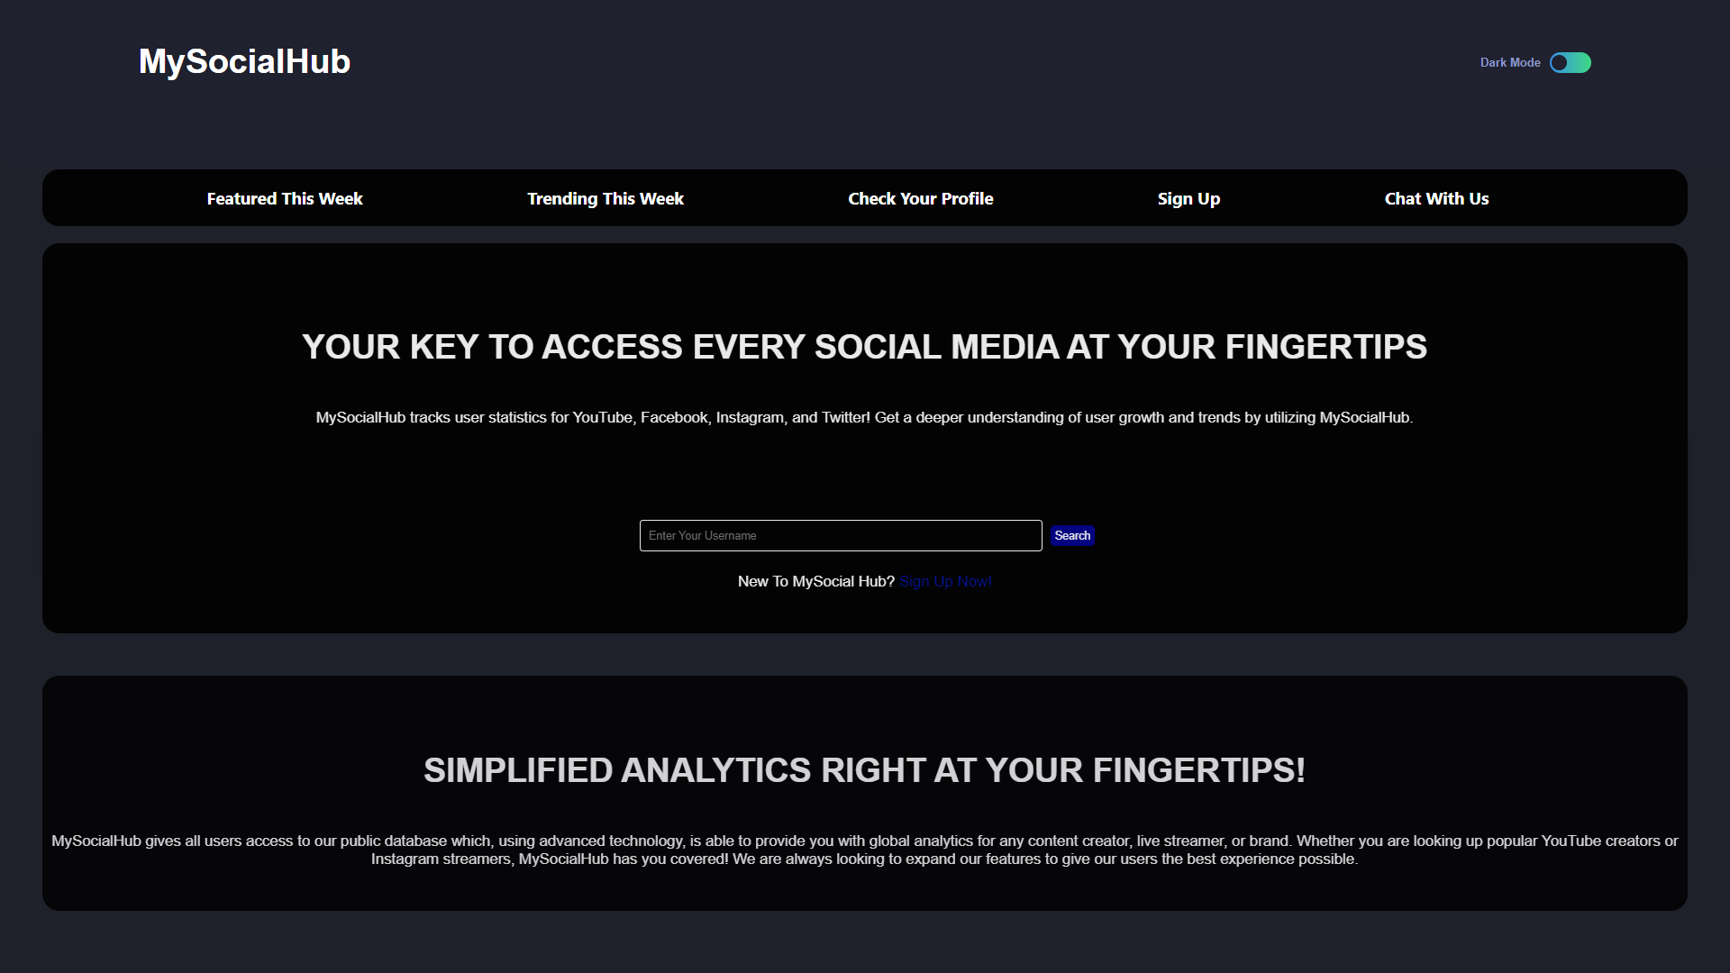

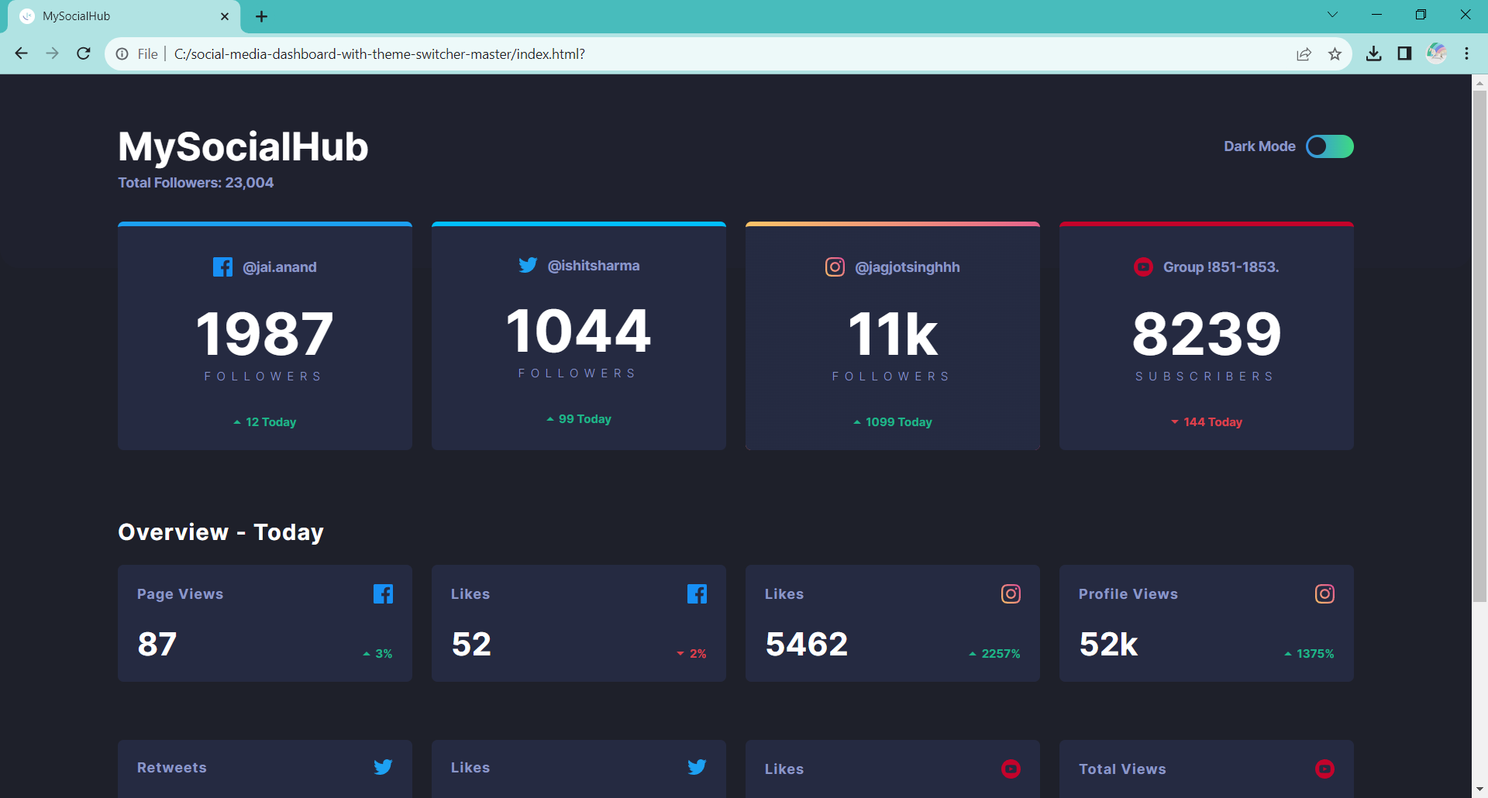

# OUTPUT:

# MAIN WEBSITE

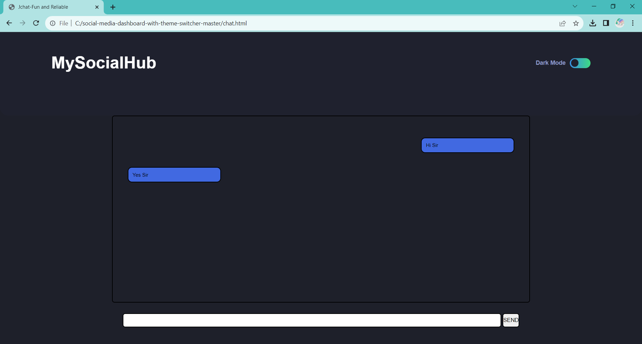

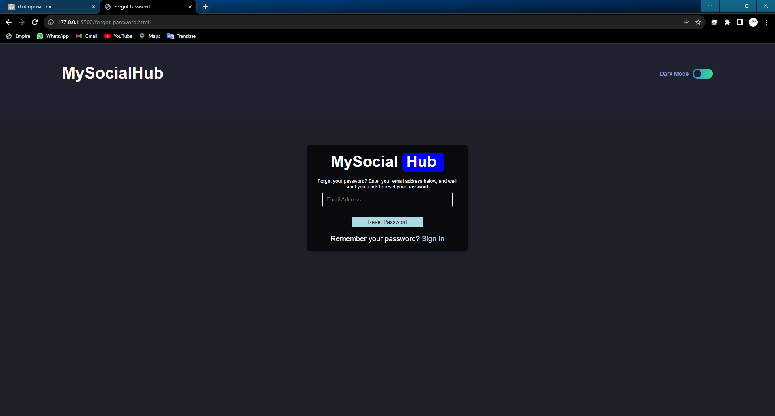

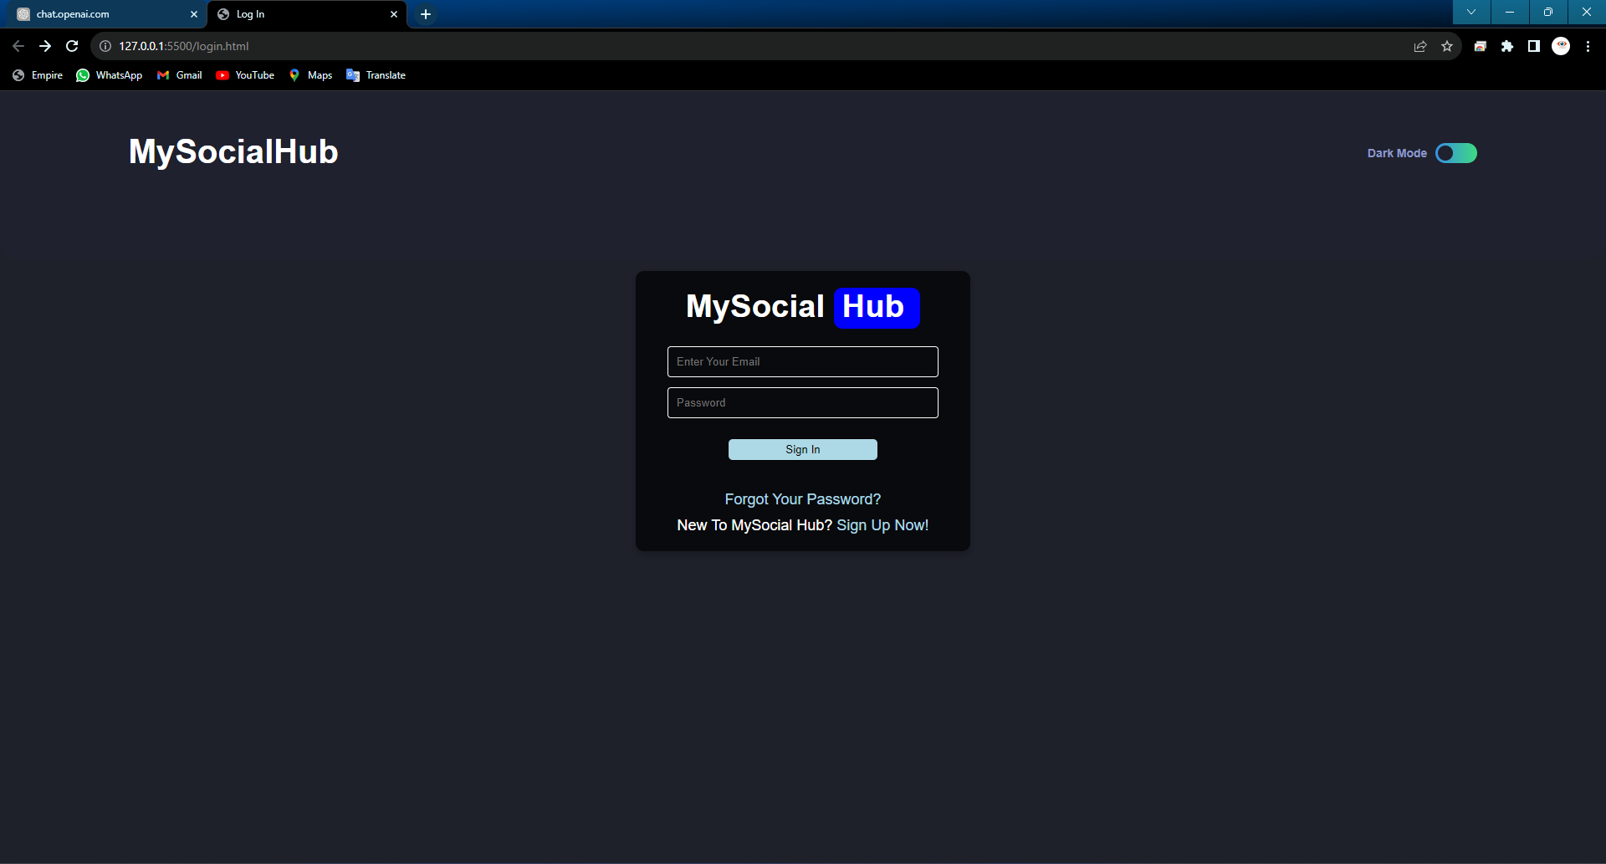

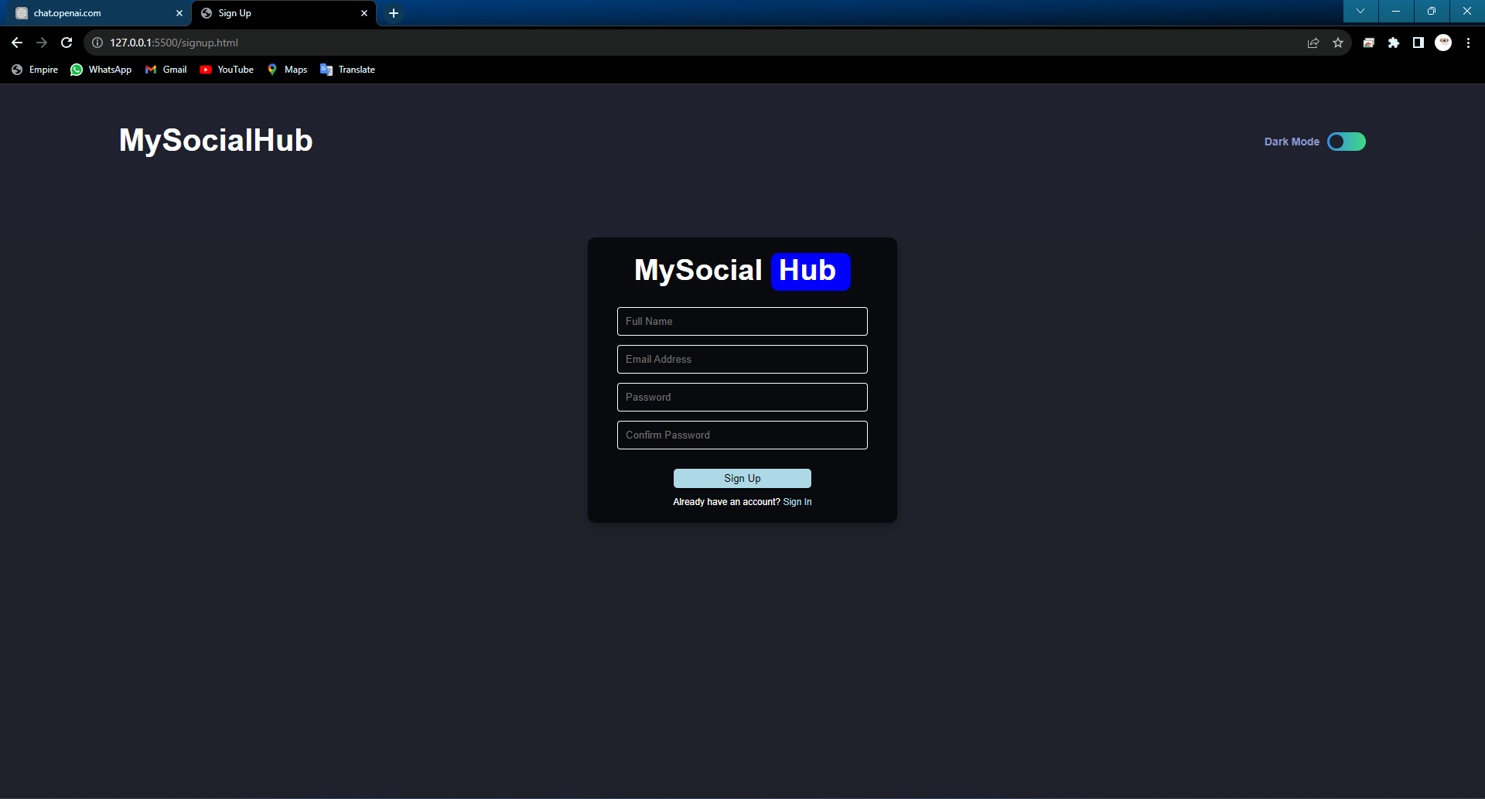

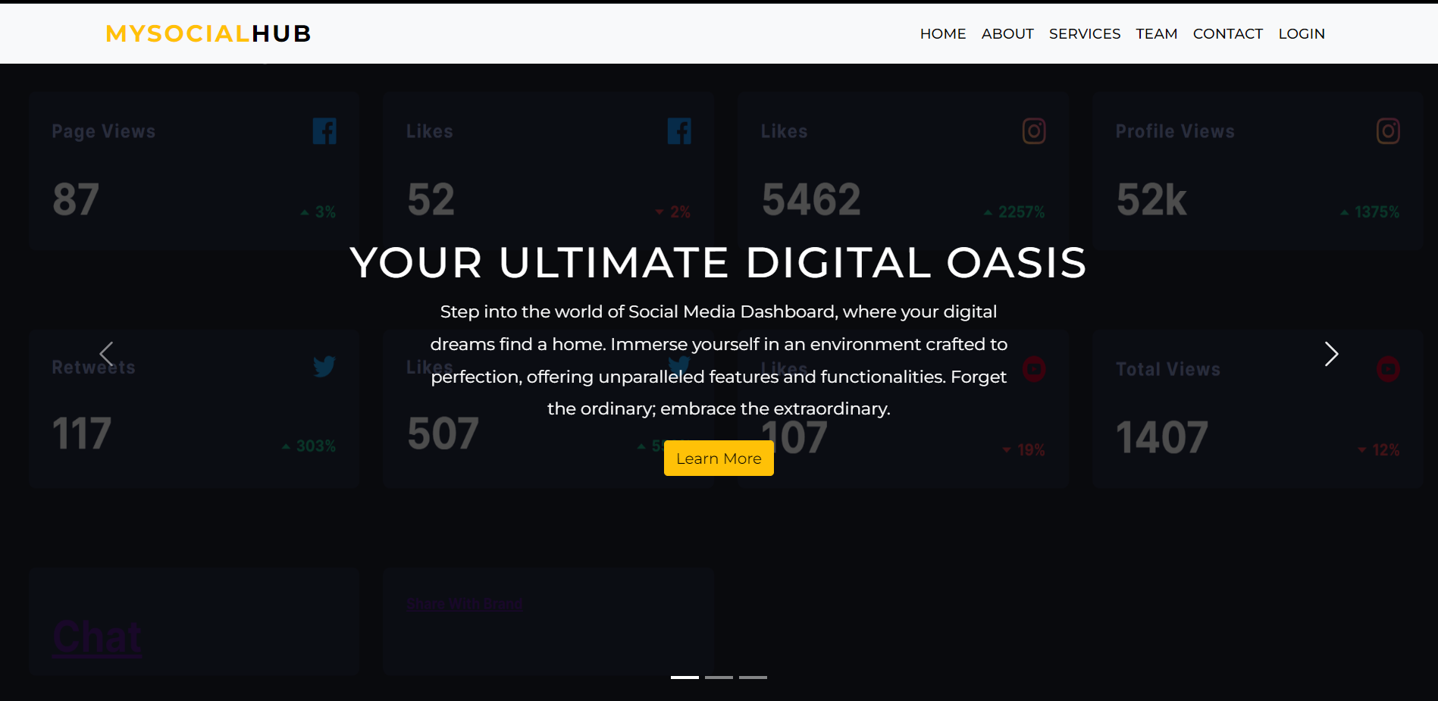

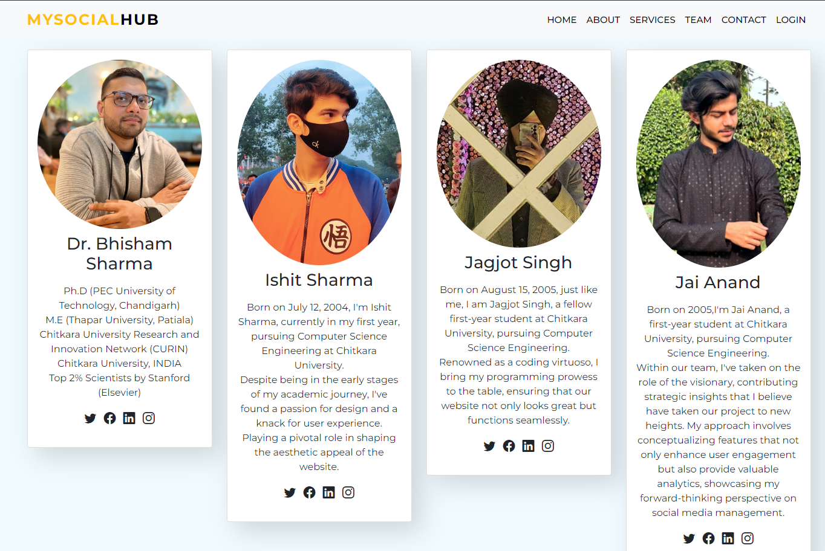

# Future Scope

* **Animations:** Approach will be taken to put several animations on several pics and contents of website so that it become more happy to use for user.
* **Ad Campaign Management:** Managing and monitoring social media advertising campaigns, tracking ad spend, and measuring ROI.
* **Social Media Listening:** Using AI and natural language processing to analyze sentiment and trends in social media conversations.
* **Support and Training:** Access to customer support and training resources to help users make the most of the dashboard's features.

# CONCLUSION

In conclusion, the design and development of a Social Media Dashboard offers a tremendous opportunity to delve into the world of web development and user experience design. This beginner-level project allows aspiring developers to put their knowledge of HTML, CSS, and JavaScript .

In summary, our Social Media Dashboard project is meticulously crafted to streamline users' social media management. With essential features like social media tracking and comprehensive analytics reports, our goal is to empower users to make well-informed decisions regarding their online presence. We are dedicated to continuously improving the user experience, taking into account user feedback, and exploring future possibilities like AI integration and enhanced security, all aimed at enhancing users' social well-being.

All in all, this project can serve as a solid foundation for the development of a fully functional Social Media Dashboard. It has the potential to inspire learners to explore new horizons in web development and design, and to create innovative solutions for simplifying the complexities of social media management.

# REFERENCES

The following references were consulted in the development of this project:

* https://socialblade.com
* https://github.com
* https://getbootstrap.com
* <https://www.w3schools.com>
* https://chat.openai.com/